HOTEL MANAGEMENT SYSTEM WITH WEB-BASED VIRTUAL TOUR
TEST CASE SCENARIO BY FEATURES
Feature | Test Input | Expected Output | Actual Output | Remarks
Booking and Reservation Management | Select room type, dates, guest info, payment method | - Booking confirmation generated with unique ID  - Room availability updated instantly  - Confirmation email sent to guest  - Payment status recorded | -Booking ID generated (#BKG12345)  - Room marked “Reserved”  - Confirmation email received  - Payment logged  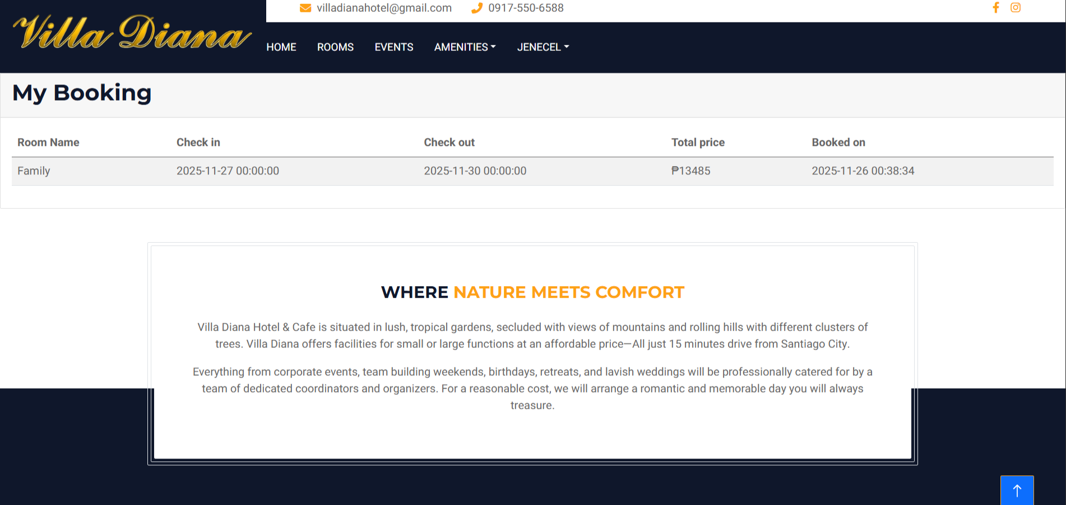 | PASSED
Room Management | Add new room with details; update room status | - Room added to system with correct details  - Status reflects changes (Available, Occupied, Maintenance)  - Updated room visible in admin dashboard | - Room “Deluxe Suite” added  - Status updated to “Maintenance”  -Visible in dashboard
Guest Management & Check-In/Out | Enter guest details; perform check-in and check-out | - Guest profile created and stored  - Check-in timestamp recorded  - Check-out timestamp recorded  - Guest history accessible in admin reports | - Guest “John Doe” profile created  - Check-in at 2:05 PM  - Check-out at 11:00 AM  - History visible in reports
Virtual Tour (360° Web Viewer) | Click “Virtual Tour” from homepage; interact with tour | - 360° view loads within 5 seconds  - Hotspots clickable and functional  - Navigation arrows work  - No broken images or missing media | - Tour loaded in 3 seconds  - Hotspots clickable  - Navigation smooth  - All images displayed correctly
Admin Dashboard and Reports | Login as admin; access dashboard; generate occupancy report | - Dashboard displays real-time metrics (occupancy, revenue, bookings)  - Reports generated accurately  - Reports downloadable/exportable in PDF/Excel | - Dashboard shows 75% occupancy  - Revenue report generated  - Report exported to PDF successfully
Authentication and Authorization | Login with valid/invalid credentials; test role-based access | - Valid users redirected to dashboard  - Invalid users denied with error message  - Role-based access enforced (e.g., staff vs admin permissions) | - Valid login redirected to dashboard  - Invalid login shows “Access Denied”  - Staff role restricted to bookings
Hotel Info/Media Management | Upload images/videos; edit hotel description | - Media uploaded successfully and displayed  - Hotel description updated  - Changes visible on guest-facing site  - No broken links or formatting | - Hotel images uploaded  - Description updated  - Changes visible on guest site  - No broken links

Objectives of the Study
This study aims to develop and implement a system tailored to the operational needs of hotels and similar hospitality establishments.
Specifically, it aims to:
- determine the current practices in hotel booking in Villa Diana Cordon
- develop a web-based virtual tour platform for Villa Diana
- asses the usability of the proposed system as perceived by end users and IT experts.

